Project Documentation: Personal Budgeting Analysis based on Survey
Project Title: Personal Budgeting and Financial Behavior Survey Analysis
Author: Yerkiman Lazer
Date: 21.12.2025
Course / Subject: Applied Data analytics
Project Description:
This project analyzes personal financial habits and budgeting behavior based on survey data collected from 50 respondents. The study aims to explore how individuals allocate their expenses, save for short- and long-term goals, and manage their overall budget. The project combines data preprocessing, exploratory data analysis (EDA), and analytical methods to provide actionable insights for financial planning and personal finance education.
Objectives:
- To understand spending and saving patterns among survey respondents.
- To identify key factors influencing personal budgeting behavior.
- To apply analytical or machine learning methods to detect patterns and relationships in the data.
- To present results with clear and meaningful visualizations supporting actionable conclusions.

2.1 Actuality & Relevance
Effective personal financial management is essential in today’s society, especially due to rising living costs and economic uncertainty. Many individuals struggle to track spending, plan budgets, and save for both short- and long-term goals, often leading to financial stress and inefficiency.
This project aims to analyze personal budgeting habits and financial decision-making using survey data. By identifying patterns in expenses and savings, the study provides insights that can help individuals make informed financial decisions. The findings are relevant for financial literacy programs, personal finance consulting, and fintech applications designed to improve budgeting practices.

2.2 Novelty & Originality
This project stands out due to its reliance on primary survey data, collected specifically to capture participants’ personal budgeting habits. Unlike many existing studies that focus on large-scale transactional datasets or generalized financial literacy assessments, our dataset incorporates subjective information, including individual spending preferences, saving goals, and financial discipline. This allows for a more nuanced understanding of real-world financial behavior.
While previous research often emphasizes financial literacy levels or general financial well-being, this project combines exploratory data analysis (EDA), data preprocessing, and analytical modeling to produce interpretable insights directly related to budgeting behavior. The results are not only descriptive but also actionable, supporting applications in personal finance education, budgeting recommendations, and user-centric financial tools.

2.3 Related work
Several studies have explored personal financial behavior and budgeting using survey or analytical approaches.
One study examined how financial knowledge impacts spending and saving habits among university students. Using survey data, the research identified strong correlations between literacy levels and effective budgeting practices, highlighting that understanding personal finances can improve financial decision-making. However, the study focused primarily on financial knowledge as an abstract measure rather than on detailed spending patterns or saving strategies [1].
Another study investigated personal financial planning and expenditure control using survey responses from a diverse population. This research provided insights into income allocation, saving behavior, and demographic influences on budgeting. While informative, it largely presented descriptive statistics without applying analytical or predictive models to detect deeper behavioral patterns [2].
In contrast to these studies, the present project focuses on detailed categories of expenses and savings, capturing not just knowledge or general behavior but actual self-reported financial decisions. The project integrates exploratory data analysis, preprocessing, and analytical modeling, producing interpretable patterns and actionable insights rather than only descriptive statistics. It also uses a small, targeted survey dataset, making it possible to understand subtle differences in budgeting behavior among participants.
Thus, the novelty of this project lies in combining survey-based primary data with analytical methods to produce actionable insights on individual budgeting behavior, bridging the gap between descriptive survey studies and model-driven financial analysis.

2.4 Methods, Algorithms, Metrics, and Datasets

Data Sources
The dataset used in this project was collected through an online survey focused on personal budgeting and financial behavior. The final dataset consists of 80 responses and contains 21 variables, including demographic information, income ranges, detailed spending categories, saving behavior, and subjective behavioral indicators such as impulse purchase frequency and saving difficulty scores.
The data includes both numerical variables (e.g., total spending, category-level expenses, savings amounts) and categorical variables (e.g., gender, income range, budgeting habits, reasons for not saving). Since the data is self-reported, it reflects real-world personal financial perceptions and behaviors.

Data Preprocessing and Feature Engineering
Several preprocessing steps were applied to ensure data quality and analytical consistency.Numerical spending-related variables were explicitly converted to numeric format. Missing values in these variables were handled using median imputation, which is robust to outliers commonly present in financial data. Categorical variables with missing values were filled using a separate "Unknown" category to preserve observations without introducing artificial assumptions.
During preprocessing, a systematic discrepancy was identified between the reported total monthly spending and the sum of individual spending categories. To reduce the impact of self-reporting bias, the sum of category-level expenses was used as a more reliable estimate of actual spending. This derived variable, referred to as effective total spending, replaced the original reported total in subsequent analyses.
Several engineered features were created to better capture financial behavior patterns: spending shares by category (e.g., food, rent, discretionary expenses),discretionary spending ratio (entertainment and shopping relative to total spending), savings intensity (amount saved relative to total spending),savings gap ratio (difference between desired and actual savings), aggregated behavioral indicators linking impulse purchases and saving difficulty.These features allowed for normalization across individuals with different income and spending levels and improved behavioral interpretability.

Analytical and Clustering methods
The analytical approach combines exploratory data analysis with unsupervised learning techniques. Exploratory analysis was used to examine distributions, correlations, and group-level differences across financial behaviors.
To identify latent behavioral profiles, a K-Means clustering algorithm was applied. Clustering features were selected to capture core dimensions of financial behavior, including impulsive spending, saving efficiency, subjective difficulty of saving, and structural expense burden. Prior to clustering, all features were standardized using z-score normalization to ensure equal contribution and prevent scale dominance.
The number of clusters was determined using silhouette analysis across multiple cluster counts. A four-cluster solution was selected as it provided a balance between separation quality, interpretability, and behavioral diversity.

Evaluation strategy
As the project does not involve supervised prediction, traditional performance metrics such as accuracy or F1-score were not applicable. Instead, evaluation focused on internal consistency, behavioral coherence, and interpretability. This included assessing cluster separation through silhouette scores, examining logical relationships between behavioral indicators, and validating derived metrics through group comparisons and correlation analysis. This evaluation strategy is appropriate for exploratory and behavior-driven financial analysis.

2.5 Results
The following section presents the key findings of the exploratory and clustering analyses conducted on the collected budgeting survey data. The results focus on identifying behavioral patterns in spending and saving habits and examining how these patterns differ across user segments, independent of income level.
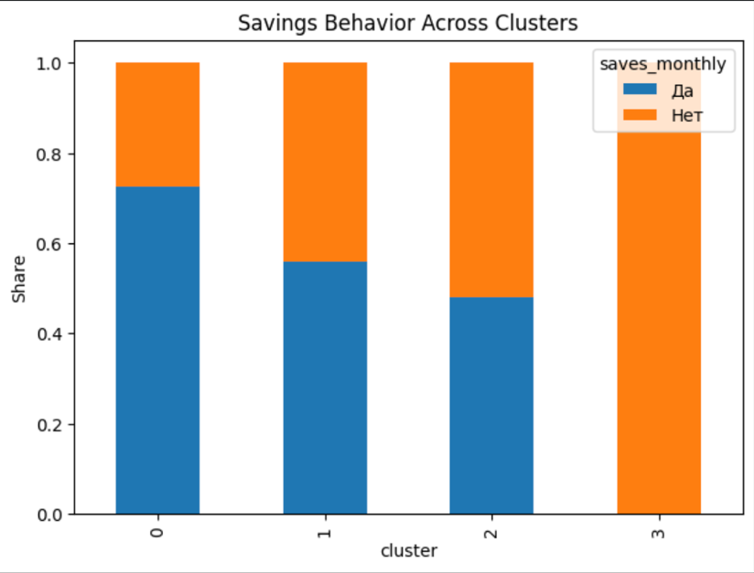
Figure 1 - Savings Behavior Across Clusters (stacked bar)
The probability of saving money on figure 1 differs substantially across the identified clusters. In some clusters, saving behavior is nearly universal, whereas in others the majority of users do not save at all. This pronounced contrast indicates that saving behavior is not primarily determined by income level, but rather by the behavioral profile of the user, including spending discipline, impulsivity, and financial habits. As a result, the presence or absence of savings reflects underlying behavioral patterns rather than purely economic capacity.
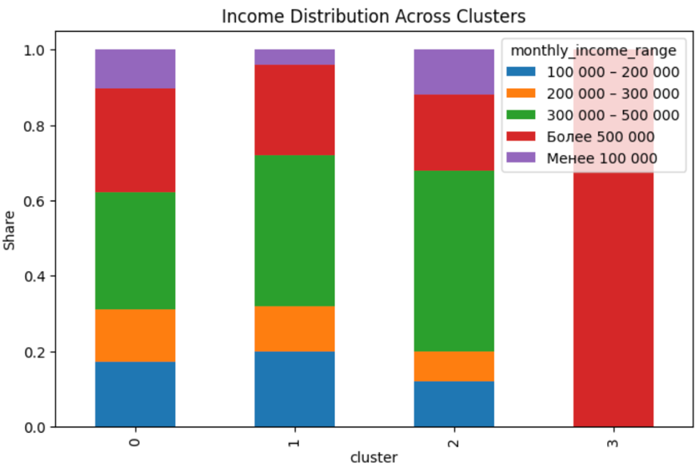
Figure 2 -Income distribution across clusters
Despite clear behavioral differences between clusters on figure 2, income levels are not directly aligned with cluster membership. Each cluster contains users from multiple income ranges, and no cluster corresponds exclusively to a specific income group. This finding suggests that segmentation based solely on income is insufficient for understanding financial behavior, as individuals with similar income levels may exhibit significantly different budgeting and saving patterns. Behavioral characteristics therefore provide a more informative basis for financial segmentation.
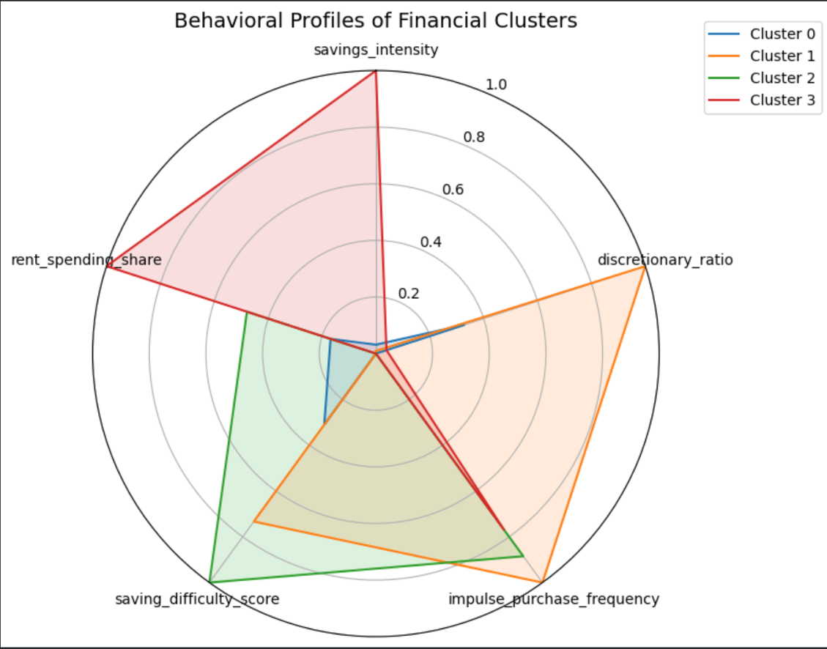
Figure 3 – Behavioral prfiles of financial clusters
The radar chart on figure 3 illustrates that each cluster possesses a distinct behavioral profile characterized by a unique combination of financial indicators rather than a uniform increase or decrease across variables. Differences between clusters emerge from the interaction of discretionary spending, impulse purchase frequency, perceived saving difficulty, savings intensity, and structural cost burden. This multidimensional structure demonstrates that financial behavior cannot be reduced to a single dominant factor and highlights the heterogeneity of budgeting strategies among users. The cluster-level interpretation reveals distinct financial behavior profiles among users. Cluster 0 represents a balanced profile characterized by moderate discretionary spending, an average level of perceived saving difficulty, and a relatively stable expense structure; these users can be described as financially adaptive individuals. Cluster 1 is marked by a high share of discretionary spending and elevated impulsivity combined with a moderate tendency to save, indicating a group of impulsive consumers whose financial decisions are driven by short-term consumption. Cluster 2 demonstrates low savings intensity alongside high subjective saving difficulty and moderate impulsivity, reflecting users who express an intention to save but struggle to do so in practice due to behavioral or structural constraints. Finally, Cluster 3 exhibits an exceptionally high share of rent expenses combined with strong saving behavior and minimal impulsivity, representing a financially constrained yet highly disciplined profile. Together, these clusters highlight the diversity of budgeting behaviors and emphasize that financial outcomes emerge from complex interactions between behavioral and structural factors rather than from income level alone.
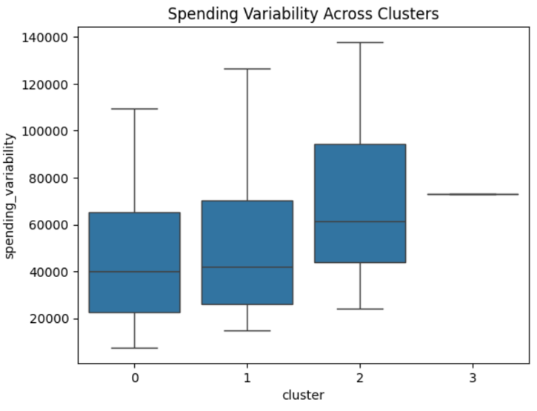
Figure 4 -Spending Variability across clusters
Clusters exhibit significant differences in the stability of monthly expenses on figure 4. One cluster demonstrates considerably higher spending variability, while others show more stable and predictable expenditure patterns. Higher variability is associated with impulsive consumption and greater difficulty in maintaining consistent savings, whereas lower variability reflects stronger financial control and more structured budgeting behavior. This suggests that spending stability is a key indicator of effective financial management.
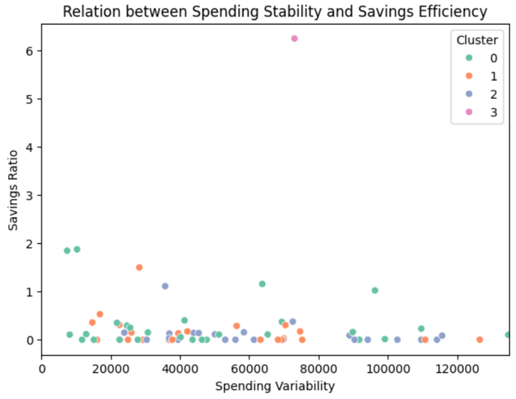
Figure 5 – Relation between stability and savings efficiency
The relationship between spending variability and savings efficiency on figure 5 is not strictly linear. Users with comparable levels of expense variability may achieve markedly different savings ratios, indicating that instability in spending does not automatically prevent saving. Some individuals are able to maintain savings despite volatile expenses through discipline, prioritization, and structured financial planning. This finding further reinforces the importance of behavioral factors in shaping saving outcomes.

2.6 Visualizations
The following section presents visual representations of the budgeting survey data, highlighting key patterns in spending and saving behaviors. The visualizations aim to illustrate differences across user segments, reveal underlying trends, and facilitate a clearer understanding of the relationships between financial habits, independent of income level
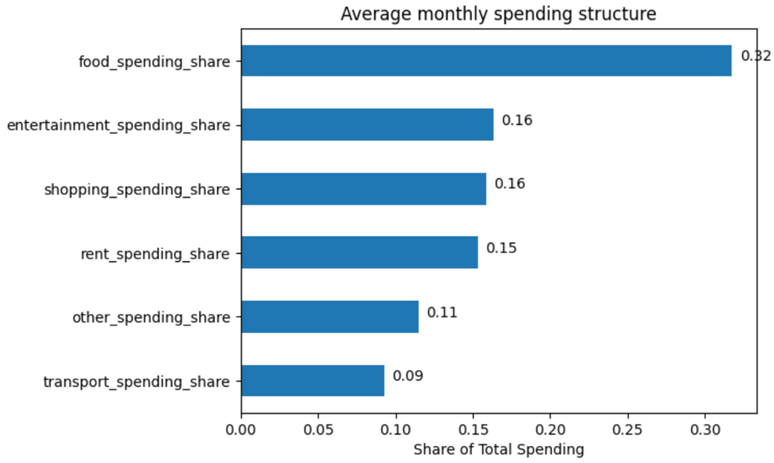
Figure 6 – Average monthly spending structure
The visualization of average monthly spending structure on figure 6 shows that food expenses constitute the largest share of total monthly spending, followed by entertainment and shopping categories. This distribution indicates that discretionary expenses account for a substantial proportion of household budgets. Such a structure suggests that non-essential spending categories represent potential leverage points for savings-oriented interventions, as even small behavioral adjustments in these areas could lead to meaningful improvements in savings outcomes.
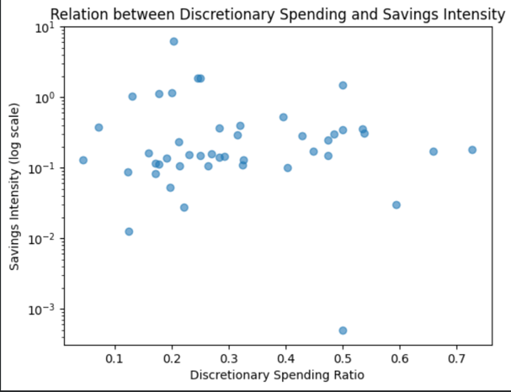
Figure 7 – Relation between discretionary spending and savings intensity
The scatter plot оn figure 7 examining the relationship between discretionary spending ratio and savings intensity reveals a weak inverse association. Individuals with higher proportions of discretionary expenses tend to exhibit lower savings efficiency. However, the presence of several outliers indicates significant heterogeneity in financial behavior, suggesting that discretionary spending alone does not fully determine saving outcomes and must be interpreted alongside behavioral discipline and structural constraint.
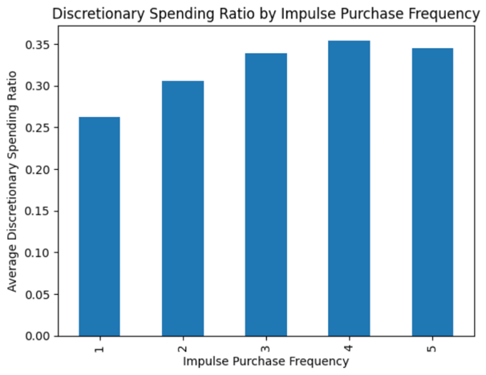l
Figure 8 – Discretionary spending ratio by impulse purchase frequency
The bar chart on figure 8 comparing discretionary spending ratio across impulse purchase frequency levels demonstrates a clear monotonic increase. As impulse purchase frequency rises, the share of discretionary spending increases consistently. This pattern supports the hypothesis that impulsive behavior directly contributes to the growth of non-essential expenses and plays a critical role in inefficient budget allocation.
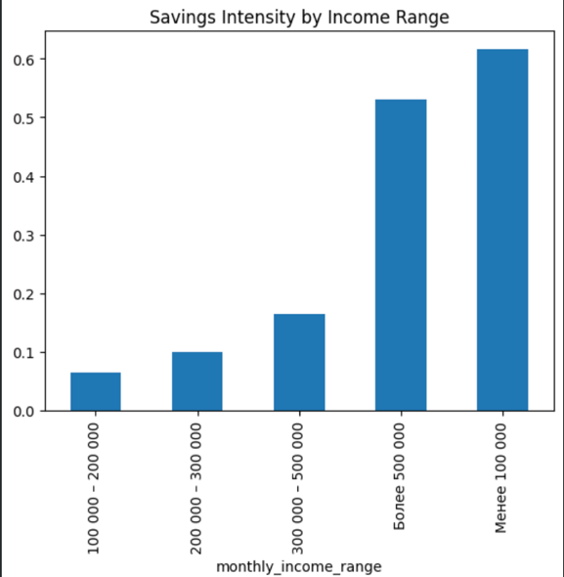l
Figure 9 – Savings intensity by income range
The visualization of savings intensity across income ranges shows a general upward trend, with higher-income individuals allocating a larger proportion of their expenses to savings. Nevertheless, the presence of positive savings intensity even among lower-income groups indicates that income alone does not fully explain saving behavior. Behavioral factors, financial discipline, and budgeting strategies also contribute significantly to savings outcomes beyond income constraints.
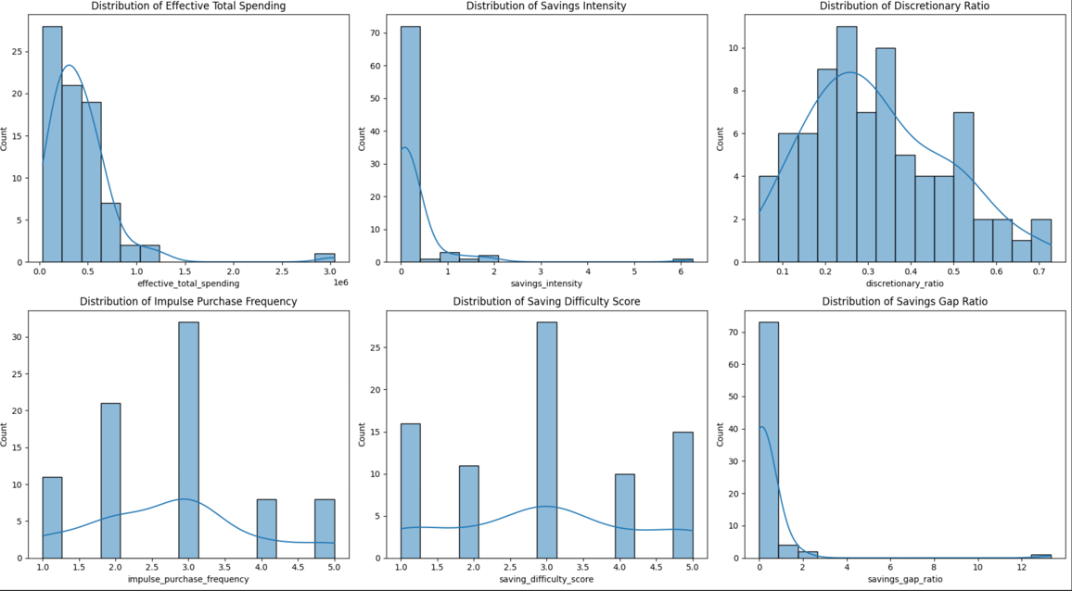
Figure 11 – histogram of effective total
The histogram of effective total spending on figure 11 is strongly right-skewed, indicating that while most respondents report moderate monthly expenses, a small number exhibit extremely high spending levels. This heterogeneity confirms the necessity of feature scaling and robust analytical methods prior to clustering.
Savings intensity displays a sharply skewed distribution, with most users showing low to moderate savings and a small subset demonstrating exceptionally high values. These extreme observations may reflect either strong financial discipline or anomalous responses, reinforcing the discriminative power of this variable for behavioral segmentation.
The discretionary spending ratio is more evenly distributed compared to other metrics, with most values concentrated between 0.2 and 0.4. This indicates that a substantial share of users allocate a significant portion of their budget to non-essential expenses, making this variable particularly suitable for identifying behavioral differences.
Impulse purchase frequency follows a discrete distribution with a peak around moderate values, suggesting that impulsive behavior is common but varies considerably across individuals. This variability highlights the presence of both financially conscious users and those prone to spontaneous spending.
The saving difficulty score exhibits a near-symmetric distribution centered around a moderate value, indicating that most respondents experience some difficulty in saving, while extreme perceptions are less common.
The savings gap ratio shows a highly asymmetric distribution with a long right tail. For most users, the gap between desired and actual savings is relatively small, but a minority displays unrealistically large gaps, making this feature useful for identifying problematic financial expectations and misaligned saving strategies.
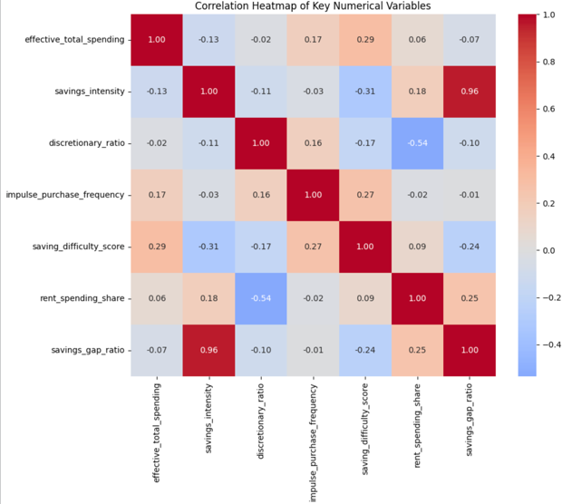
Figure 11 – Correlation Heatmap of Key numeric variables
The correlation heatmap reveals several meaningful relationships between key financial behavior indicators. Savings intensity shows a very strong positive correlation with the savings gap ratio, which is intuitively consistent: the higher the savings target relative to an individual’s financial capacity, the larger the gap between desired and actual savings. The discretionary spending ratio is negatively correlated with rent spending share, reflecting a structural trade-off between mandatory and non-essential expenses. Additionally, impulse purchase frequency is positively associated with the perceived difficulty of saving, confirming that impulsive behavior complicates the saving process. Overall, the observed correlations are moderate rather than extreme, indicating that financial behavior is inherently multidimensional. This supports the use of clustering methods to capture complex behavioral patterns that cannot be explained by pairwise relationships alone.
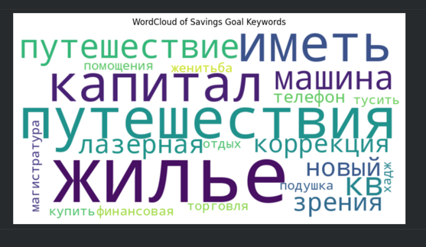
Figure 12 – Word Cloud Analysis of Savings Goals
The word cloud generated from open-ended survey responses highlights the most frequently mentioned savings goals, which are primarily related to housing, travel, vehicle purchases, capital accumulation, education, and health. These findings suggest that users’ financial objectives are strongly life-oriented and practical rather than abstract monetary targets. This reinforces the real-world relevance of the dataset and enhances the practical value of the project, as the identified goals align closely with common long-term financial planning priorities.

Conclusion
The combined results from exploratory data analysis, visualizations, and clustering approaches provide a comprehensive understanding of personal financial behavior and its determinants. One key finding is that financial habits and outcomes are highly heterogeneous across individuals and cannot be adequately predicted by income level alone. While income certainly influences financial capacity, our analyses highlight that behavioral factors—such as discretionary spending patterns, impulsivity in purchases, perceived difficulty of saving, and stability of monthly expenses—play a critical role in shaping savings outcomes and overall financial well-being.
The visualizations further emphasize the nuanced ways in which these behaviors interact. For instance, individuals with high impulsivity scores tend to experience greater difficulty in accumulating savings, even when their income or spending capacity is relatively high. Similarly, patterns of discretionary spending show that prioritization of non-essential expenses often correlates with larger gaps between intended and actual savings, underscoring the importance of financial discipline and planning. Clustering analyses reinforce these observations by identifying distinct behavioral segments, each characterized by unique combinations of spending and saving tendencies. These segments provide actionable insights for tailoring financial advice, interventions, and tools to specific user profiles.
Overall, the evidence strongly supports a shift from income-based to behavior-driven approaches in personal finance. By focusing on the behavioral determinants of financial outcomes, financial institutions, educators, and app developers can design more effective personalized budgeting tools, targeted educational content, and behavioral nudges that encourage better financial decision-making. These insights establish a robust foundation for future work on predictive models of financial behavior and the development of interventions aimed at improving financial health at the individual level.

References
[1] Financial literacy and budgeting behavior among university students. Journal of Contemporary Accounting and Finance Management.
[2] Financial behavior and well-being: Survey-based analysis of personal finance management. In Lecture Notes in Networks and Systems (pp. xxx–xxx). Springer.

